IBM WRT Tool

Log into the tool using the below link
https://www.ibm.com/support/operations/myrequests/index.jsp?include=initiateRequest.jsp&menuName=Menu3_1

- Thereafter go to initiate a request, select Region, Country and Type of Request
- MEA, South Africa and Service Engagement Request
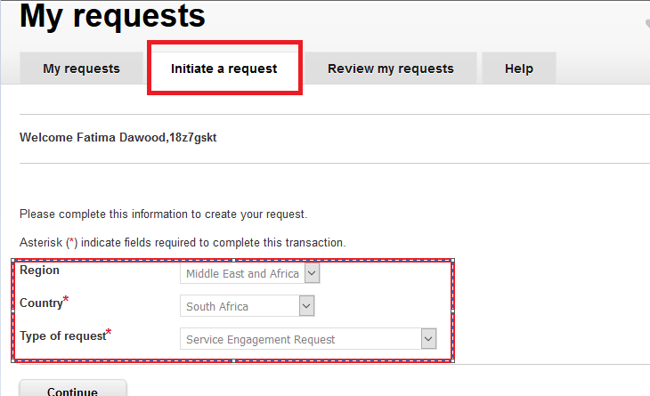

- Type of request may Vary, depending what you require.

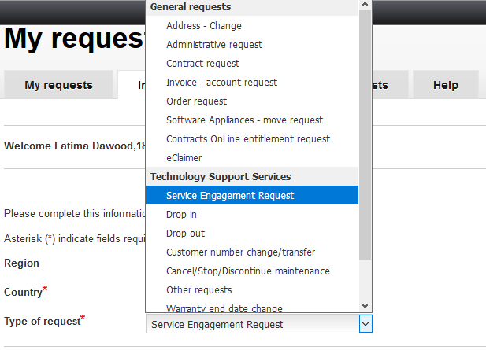

Thereafter on the next prompt, fill out all the mandatory Information, Include CEID’s and Cust No’s
Also include your Request description, upload all the necessary files.
See below screenshot, they are very straight forward, just follow prompts and submit.
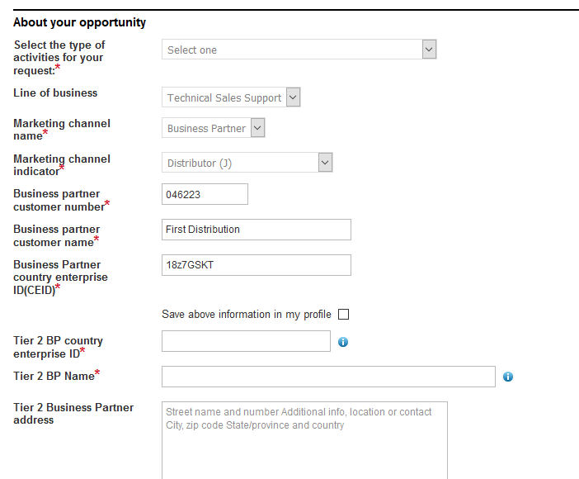
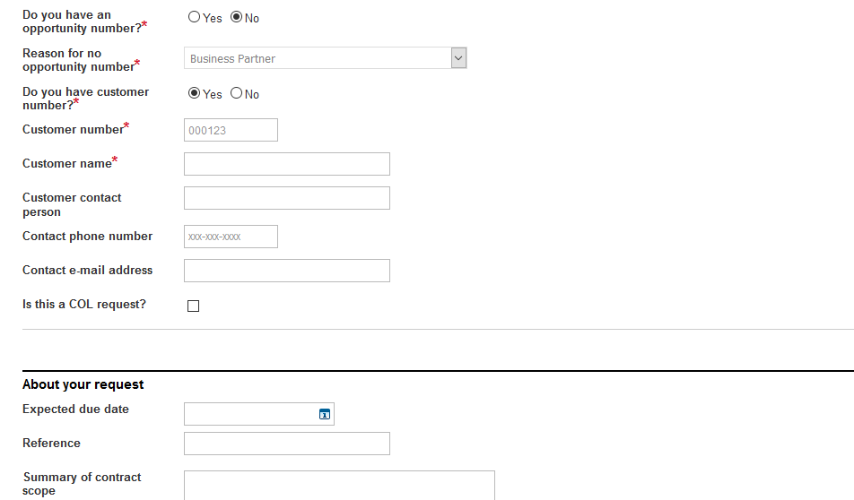
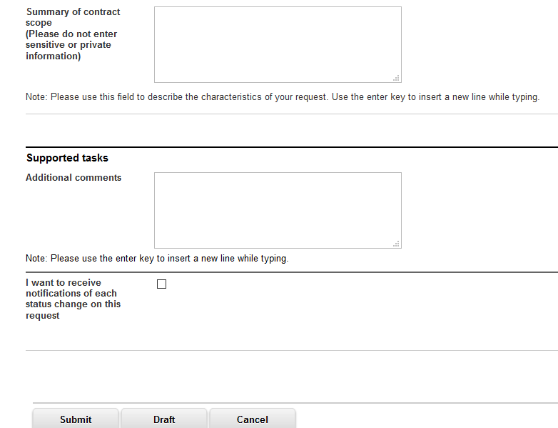

After Submitting your request you will receive a Reference No that No can be used to track your request. Example below:
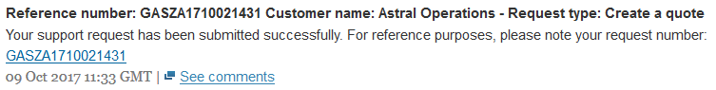
Kindly note it takes 3-5 working days before you receive any feedback!

