IBM SW Processes
New License Quote – (On Prem)
- Quote Request
- Receive a quote request via Email from Client, Alias or Sales Specialist
- Receive a bid from IBM Bid Alias

- Quoting Data
- Check if Reseller is Authorised (BP Auth List – we get this form Lesly at IBM)
\\filer2\Data\IBM Software\Year 2017
- Check if EU is Authorized (PA Online)
https://www-01.ibm.com/software/passportadvantage/pao_reseller.html
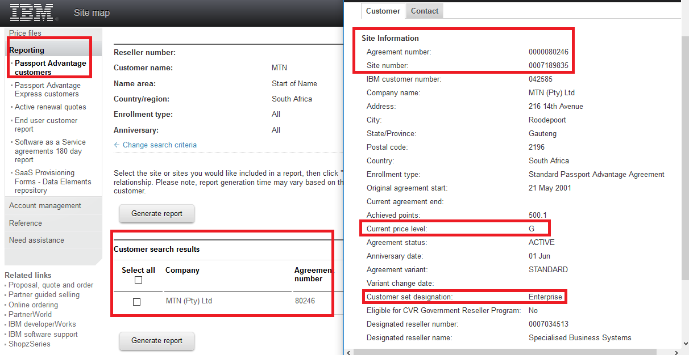
- Check if BP is authorised for requested product group (BP Auth List)
\\filer2\Data\IBM Software\Year 2017
- Check IBM Hotlist (We get this from Lesley at IBM) to see if EU is currently undergoing Audit, if the EU is on that list, we would require compliance approval from Andries/Kathryn to quote, taking into consideration if it is for a New Project or Over-Deployment
\\filer2\Data\IBM Software\Year 2017
- Check to see if request is clean, quantities are visible and if a server needs to be quoted then information regarding PVU is given (eg. Sever make, model, processor and core quantity)
https://www-112.ibm.com/software/howtobuy/passportadvantage/pvucalculator/pvucalc.wss?portal=external

- Quoting Process
- Once you have all the required information, open pricebook and quoting template.
\\filer2\Data\IBM Software\Year 2017
- Input the Reseller Info, Cust Info, your name, dates, quote no, ISU, Part no’s and descriptions, item points, product group, maintenance period and then as per the EU Designation and Band level from IBM PA Online you will insert the price from pricebook using respective band level, then add margins to reseller price as per IBM VAD Guide depending on whether client is SPP (Support Provider Partner) or PA (Passport Advantage).
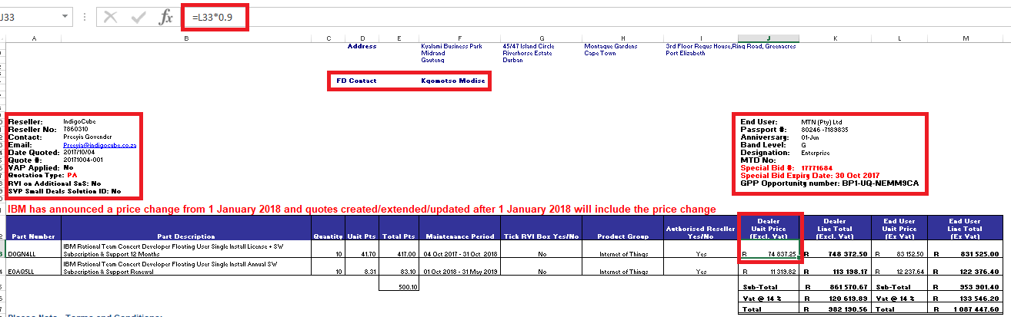
- -For SPP Clients, a mail should be sent to Lesley at IBM so she can share site details in order for us to quote.
- Thereafter quote is sent to SS to send to client and if SS is not available the quote is sent to the client directly.
Keep in Mind that all ELA clients will not get Instant Rebate for PA Quotes!
Passport Advantage Margins after 01 April 2017
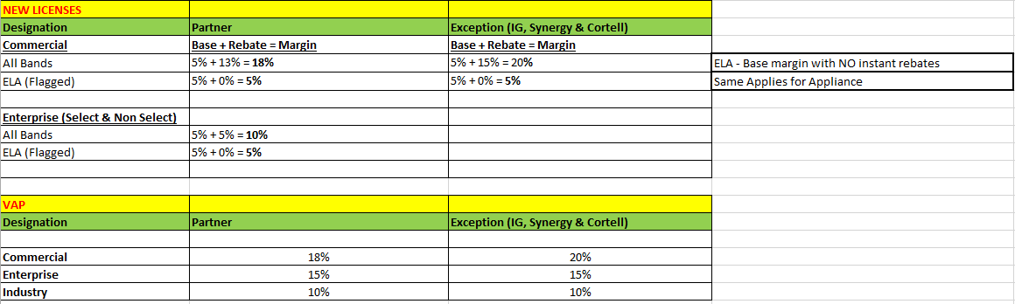
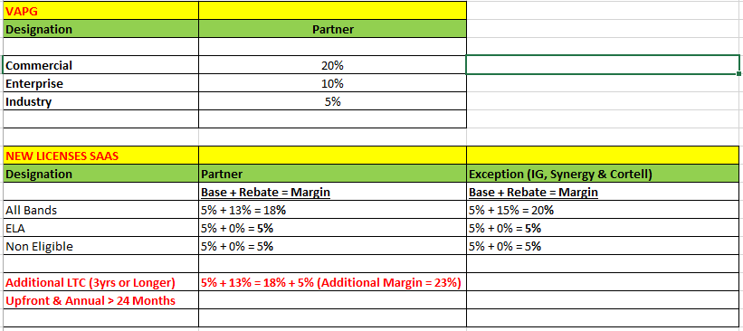
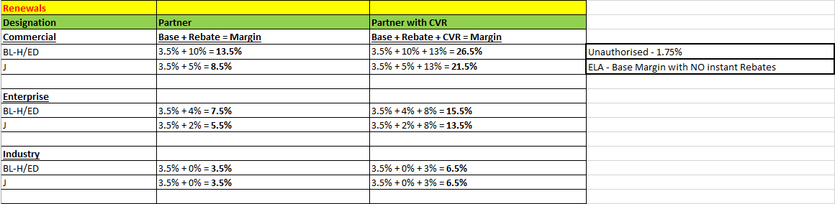
Support Provider New License Margins after 01 April 2017
Level | Base
BL-H/ED | 5%
I&J | 2.5%
ELA | 1%

Support Provider for | SPP  Margin | GB-Com  (Commercial) | GB-Non Select (Enterprise)
Cognos/Filenet/Sterling/  Enterprise Marketing  Management(Unica)/  B2B Integration/WebSphere Commerce | 15% | 13% | 5%
SPSS & Smarter Cities,  (I2) | 15% | 13% | 5%
Optim/Infosphere | 15% | 13% | 5%

Only Base Margin and SPP Margin applies for customers that are:
GB-Ent Select
Industry/Ent
Levels I&J
ELA

Bid Needed for SPP VAP Margin
Designation | BP
Commercial | 15%
Enterprise | 15%
Industry | 10%

Bid Needed for SPP VAP GoE Margin
Designation | BP
Commercial | 20%
Enterprise | 10%
Industry | 5%

New License Quote – (SaaS)
- The quote request and quote data is the same, only difference is in the quoting process

- Quoting Process

- Log onto IBM PA Online
https://www-01.ibm.com/software/passportadvantage/pao_reseller.html

- Go to Create a quote, follow steps then when selecting parts go to Browse SaaS, select parts, follow steps and submit quote.

- Note that we cannot price Monthly and Restricted parts this will need to go to IBM SS for assistance.
- The quote will come back to you as a bid after approvals
- Open quoting template, copy and paste information from bid onto template and send to SS/ Client if SS not available.
Keeping in mind that with SaaS, Instant rebate is only given if the partner is Eligible as per VAD Guide.
