IBM ISAT Process
- Quote Request
- Receive a quote request via Email from Client, Alias or Sales Specialist
- Receive a WAXIT from IBM

- Quoting Data
- The TSS Request form should be filled out with Tabs 2, 8 & 9 been the most important.

- Serial numbers, machine types, models and SLA should always be provided
- Config files should always be provided if the maintenance is for new machines.
- BP and EU name should be given, also their respective CEID’s and Cust No’s should be shared with us.
- If a renewal then the contract ID that needs to be renewed will have to be given

- Quoting Process
- Once you have all the required information, open ISAT (IBM Service Assistant), log in with your details then accept T&C’s

- Once on ISAT, go to Proposal, new, type in the EU name, Agent Identifier then next.
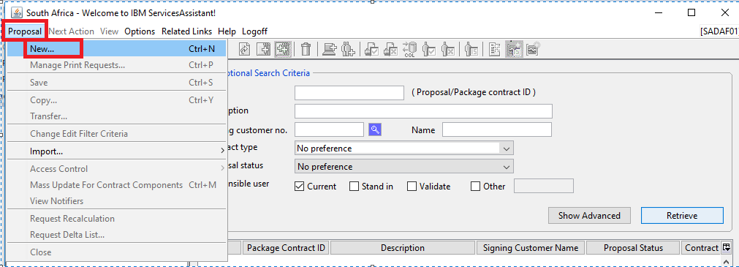
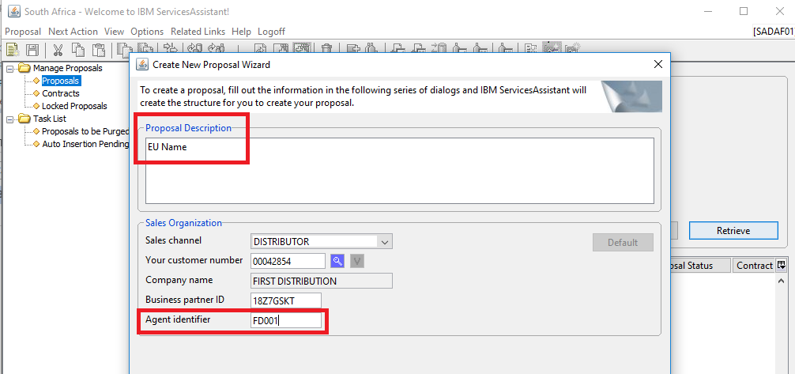

- Then the next page prompt will ask if IBM Registered, click No, Under Cust Name and Cust Address put in the EU Name, click Next.
- 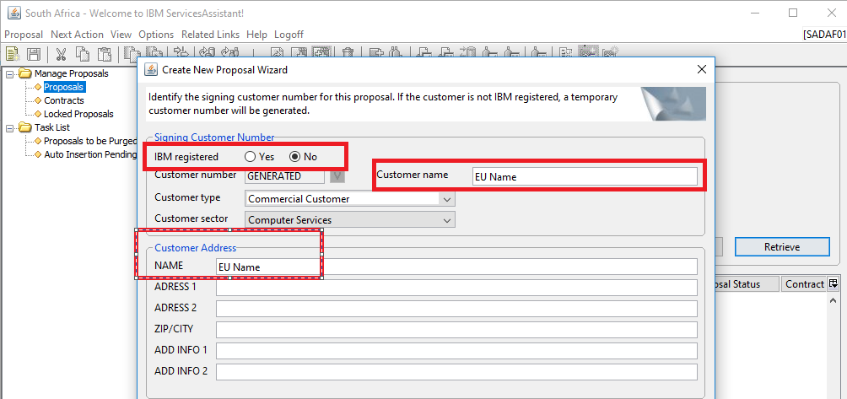

- The next page prompts for currency, select South Africa Rand
- Then click next and next again
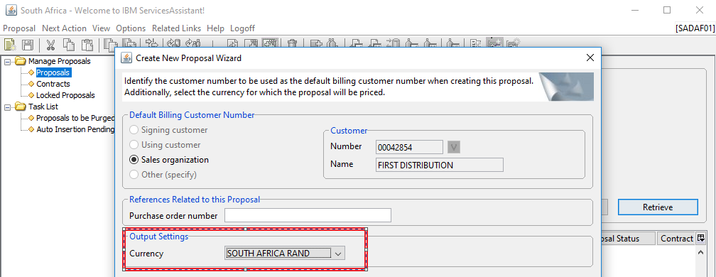

Select your Contract Start Date, then Service Suite Standard/Prepaid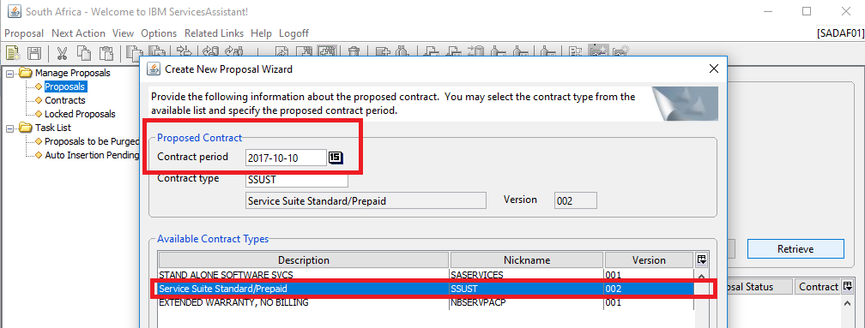

Choose the Prepayment option, then pricing option for the period, use the right arrow and move over, click finish.
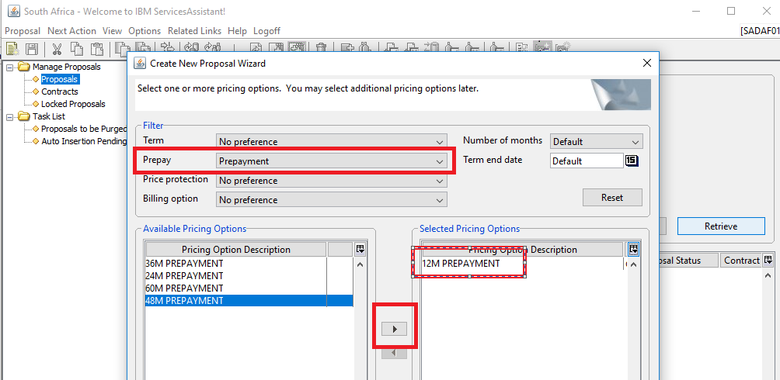
- On Cust ref Text input – For pricing purposes only, not for signature, then click save.

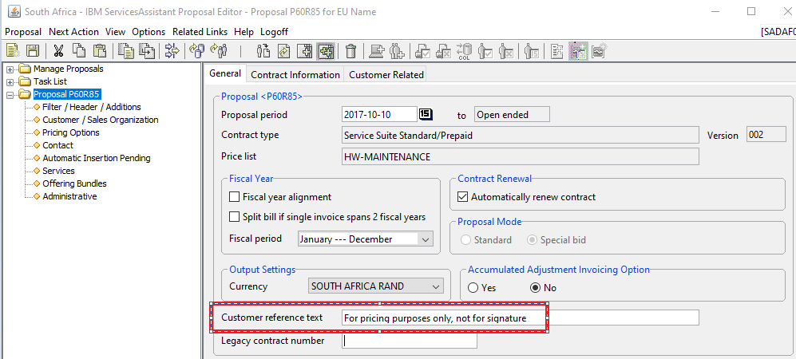
- Depending on what files you have CSV or CFR, you can go two ways in pricing the machines.
- If CFR file, go to Proposal, import, then select CF Report

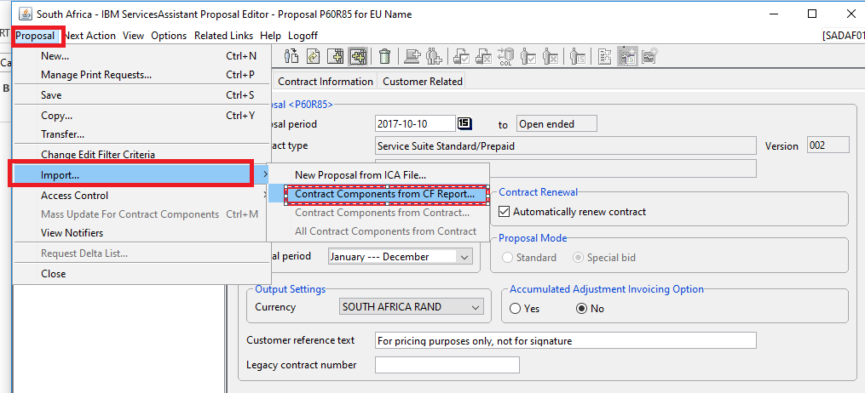
- If CSV, go to Next Action, Add services, choose HW Maintenance, then click on next
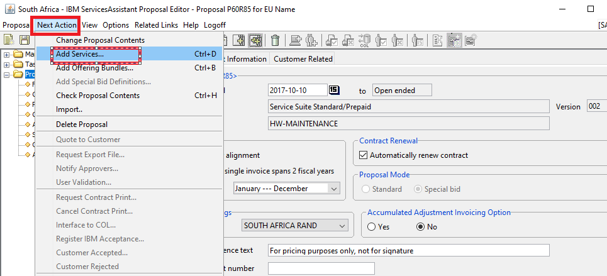
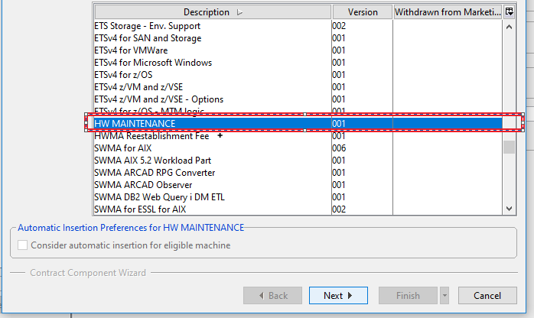
- Go to retrieve Inventory, select the CSV file from selected folder.
- Once machines reflect select the SLA and save.

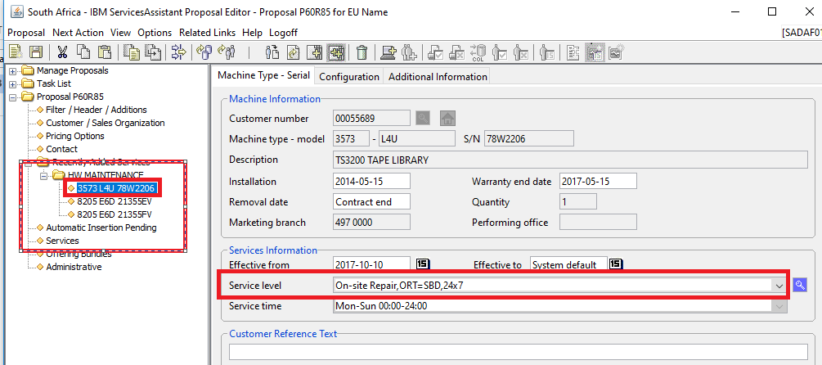

- Thereafter, go to Next Action, quote to customer, select 90 days, then click Validate
- Once System is validated, then click Next Action, select User Validation, after User Validation, go to Next Action, Request Contract Print.
- Print the BP Contract and Save (Version 9)
- Print EU Contract and Save (Version 11)
- Print ODS File (Request Export File) and Save (Version 3, single line red BP)
- Save all the files and exit ISAT.

- Keep in Mind that all ISAT Quotes need to be sent for Validation to the STS Team via WRT Tool

